5. Project Methodology
5.1 Overall Methodology
The project follows a structured methodology to develop a phishing email detection system that can identify suspicious emails and explain its predictions. The workflow consists of dataset preparation, preprocessing, baseline modelling, transformer-based modelling, handcrafted feature extraction, hybrid model development, evaluation, explainability, and system demonstration.
Figure 5.1.1: The Overall Methodology
The methodology is divided into two main parts:
- NLP-based Classification
- Explainable AI (XAI)
The NLP-based classification part focuses on identification of an email is phishing or legitimate. The classical NLP models establish an initial performance level using traditional text classification. Transformer models are then evaluated to capture deeper contextual patterns in email content. Handcrafted phishing-related features are added to represent specific characteristics commonly associated with phishing emails. These features are combined with transformer representations to develop and evaluate hybrid architectures. This process allows different modelling approaches to be compared before selecting the final classification model.
The XAI part focuses on making the model's predictions understandable. A high classification score alone does not show why an email was classified as phishing. Explanations can identify the words or phrases that influenced the prediction and help users understand the model's decision. This is important for a security application because users need meaningful information to decide whether the email is phishing or legitimate.
The two parts serve different purposes. NLP provides classification capability, and XAI provides interpretability. Combining them produces a system that can provide both a classification result and an explanation. The final stage demonstrates this complete process using email inputs and the resulting prediction and explanation.

5.2 Process of Experiments: NLP-based Classification
The experimental process was designed as a sequence of stages, beginning with the preparation of the phishing email dataset and ending with the comparison of model performance.
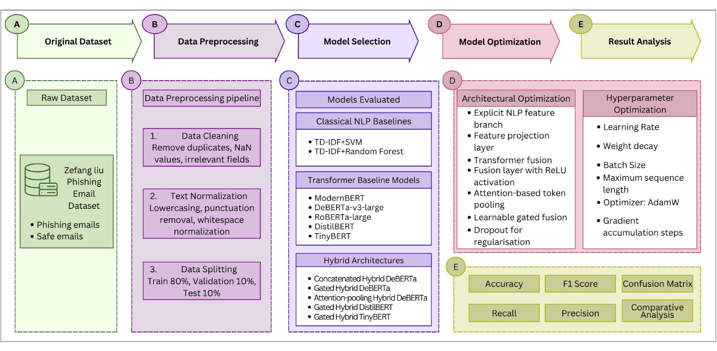
Figure 5.2.1: An approach to email classification is presented as follows: Frame (A) shows that the dataset is collected. (B) Data preprocessing steps are applied to generate the pre-processed dataset. (C) Several baseline models are evaluated. (D) Hybrid architectures are developed through architectural and hyperparameter experimentation. (E) The model results are analysed using performance metrics.
The model development followed a progressive experimental process. The initial stage established classical NLP baselines using TF-IDF with Logistic Regression and Support Vector Machine. These models provided reference performance for the subsequent experiments.
The next stage involved training several pretrained transformer models as standalone classifiers. These included RoBERTa-large, ModernBERT-large, DeBERTa-v3-large, DistilBERT and TinyBERT. The standalone transformer experiments established reference performance before introducing additional handcrafted features.
The following stage focused on hybrid model development. The hybrid approach combined contextual information from a pretrained transformer with explicitly added phishing-related NLP features. Different feature-fusion strategies were investigated to examine how the two sources of information could be integrated. These experiments included feature concatenation, gated fusion and attention pooling.
Hybrid experiments were conducted using different transformer backbones, including DeBERTa-v3-large, DistilBERT and TinyBERT. This allowed the study to examine whether hybridisation produced consistent performance across transformer architectures and model sizes.
The final stage involved comparative evaluation of the experimental models. The results were analysed using accuracy, precision, recall, F1-score and confusion matrices. The analysis considered the effects of transformer architecture, handcrafted features and fusion strategy on email classification performance. The selected model was then used as the basis for the explainability component and system demonstration.
5.2.1 Dataset Description
The dataset used in this project is the zefang-liu/phishing-email-dataset (2026). It contains email messages labelled as either Safe Email or Phishing Email. The dataset provides labelled textual data suitable for supervised phishing email classification.
The original dataset contains 18,650 records. After the cleaning and preprocessing procedure, 17,519 valid records were retained. The final dataset consists of 10,978 safe emails and 6,541 phishing emails.
Table 5.2.1.1: Original Dataset Description
Name | Number of records
Columns | 3
Safe Email | 11322
Phishing Email | 7328
Missing Values | Email text (16)
Empty email texts | 19
Duplicate email text | 1112
Different label | 1
The processed dataset was divided into three fixed subsets using a stratified split with random seed 42. The training set contains 14,015 records, while the validation and test sets each contain 1,752 records. The test set was kept separate from model development and was used only for the final performance comparison.
5.2.2 Data Preprocessing
Data preprocessing was performed to improve the consistency of the email text while preserving information that could be useful for phishing detection. The same preprocessing procedure was applied before the data was used for model training and evaluation.
First, removed the non-required column named ‘unnamed’. Then missing or empty email texts were removed. Records containing different labels were also removed, followed by the removal of exact duplicate emails. The remaining text was processed using HTML entity decoding and Unicode NFKC normalisation.
Control characters were removed, while HTML/XML tags were removed without discarding the visible text content. Line breaks and excessive whitespace were also normalised. The original textual information was otherwise retained.
No stop-word removal, stemming, lemmatisation, or aggressive removal of punctuation and URLs were performed. These elements can contain useful signals for phishing detection. Finally, the class labels were converted into binary values, with Safe Email = 0 and Phishing Email = 1.
Table 5.2.2.1: Dataset description after preprocessing
Name | Number of records
Columns | 4
Safe Email | 10978
Phishing Email | 6541
Missing Values | Email text (0)
Empty email texts | 0
Duplicate email text | 0
Different label | 0
Label encoding (Safe email) | ‘0’
Label encoding (Phishing email) | ‘1’
5.2.3 Dataset Split
After preprocessing, the dataset was divided into training, validation, and test subsets. A stratified split with a fixed random seed of 42 was used to maintain a consistent class distribution across the three subsets.
Table 5.2.3.1: Dataset split
Set name | Percentage | Number of data
Train | 80 | 14015
Validation | 10 | 1752
Test | 10 | 1752
The training set contains 14,015 emails and was used for model training. The validation set contains 1,752 emails and was used to monitor model performance during training and support model selection. The remaining 1,752 emails were reserved as the test set.
The test data was not used for training or model selection. Keeping this set separate allowed the final models to be evaluated under the same unseen test conditions.
5.2.4 Baseline Models
Baseline models were established before developing the hybrid architectures to provide reference points for evaluating the effectiveness of the proposed approaches. Both classical NLP and pretrained transformer models were considered to provide a broader comparison across different modelling approaches.
A. Classical NLP Baseline Models
Classical NLP baselines were included to establish a simple and interpretable benchmark for the phishing email classification task. This provides a reference for comparing traditional text-based machine learning approaches with the more advanced transformer and hybrid models.
Two traditional machine learning approaches were evaluated using TF-IDF (Term Frequency-Inverse Document Frequency) for text representation:
TF-IDF + Support Vector Machine and Random Forest
TF-IDF + SVM and Random Forest were included as classical NLP baseline for the phishing email classification task. In both approaches, the preprocessed email text is converted into numerical feature vectors using Term Frequency-Inverse Document Frequency (TF-IDF), which represents the importance of terms within individual emails and across the overall collection. The resulting TF-IDF representations are then provided to either a Support Vector Machine (SVM) or a Random Forest (RF) classifier to classify between safe and phishing emails. SVM provides a traditional classification approach, while Random Forest combines multiple decision trees to produce the final classification. These models provide a traditional NLP benchmark for comparison with the transformer-based models (Dadgar, Araghi and Farahani 2016; Sjarif et al. 2019).
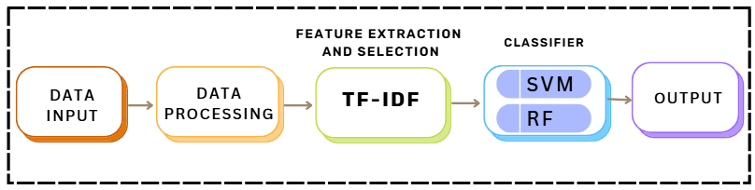Figure 5.2.4.1: Process of Classical NLP Baseline Models
B. Transformer Baseline Models
Each baseline model received the processed email text as input and performed binary classification between Safe Email and Phishing Email. The models represent different transformer architectures and model sizes, allowing the study to compare both larger and more lightweight pretrained approaches.
RoBERTa-large
RoBERTa-large is a transformer-based language model designed to improve the pretraining approach used by BERT (Liu et al. 2019). It consists of 24 transformer encoder layers, with a hidden size of 1024 and 16 attention heads. The model uses self-attention to capture contextual relationships between words and produces contextual representations that can be adapted for downstream text classification tasks.
ModernBERT-large
ModernBERT-large is a modernised bidirectional, encoder-only Transformer based on the BERT architecture. It was pretrained on approximately 2 trillion tokens of English text and code and supports a native context length of up to 8,192 tokens. The architecture introduces improvements such as Rotary Positional Embeddings (RoPE), local-global alternating attention, unpadding, and Flash Attention, which improve long-context processing and computational efficiency. The large version contains 28 Transformer layers and approximately 395 million parameters. In this research, ModernBERT-large was evaluated as a pretrained transformer baseline for phishing email classification (Answer.AI 2024).
DistilBERT
DistilBERT is a smaller transformer model developed through knowledge distillation from BERT. It retains the main contextual language-understanding capabilities of BERT while using a reduced architecture. The commonly used DistilBERT-base model contains 6 transformer layers, 768 hidden dimensions, and 12 attention heads, making it considerably lighter than larger transformer models (Sanh et al. 2019).
TinyBERT
TinyBERT is a compact transformer model created using knowledge distillation to transfer knowledge from BERT into a smaller architecture. The TinyBERT model used in this research contains 4 transformer layers, a 312-dimensional hidden representation, and 12 attention heads. Its smaller architecture provides reduced computational requirements while retaining the ability to perform natural language understanding tasks (Jiao et al. 2020).

DeBERTa-v3-large
DeBERTa-v3-large is a pretrained Transformer encoder designed to improve contextual language understanding. The DeBERTa architecture introduces disentangled attention, where word content and position information are represented separately when calculating attention between tokens. This allows the model to capture both the meaning of words and their relative positions more effectively.
The V3 version further improves the original DeBERTa through ELECTRA-style Replaced Token Detection (RTD) pretraining and Gradient-Disentangled Embedding Sharing. These changes improve the efficiency of pretraining and the quality of the resulting language representations (He, Gao and Chen 2021).
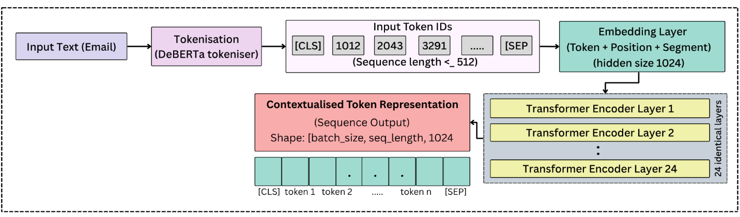
Figure 5.2.4.2: Architecture of DeBERTa-v3-large
The DeBERTa-v3-large model used in this research contains 24 Transformer layers, a 1024-dimensional hidden representation, 16 attention heads, and a 128K-token vocabulary. The official model documentation reports 304M backbone parameters, with an additional 131M parameters in the embedding layer.
DeBERTa-v3-large processes the tokenised email through its Transformer encoder layers and produces a contextual representation for each token. For an input sequence of n tokens, the final encoder produces:
$${H = \left[h_{1}, h_{2}, …, h_{n}​\right], h_{i}​∈R}^{1024}$$
In this project, DeBERTa-v3-large was used as the main pretrained backbone for three hybrid architectures. It receives the processed email text and produces contextual representations, which are then combined with the 12 handcrafted phishing-related NLP features in the proposed hybrid models.

5.2.5 Hybrid Architectures
The hybrid architecture extends pretrained transformer models by introducing a second branch containing handcrafted phishing-related NLP features. The two branches provide different types of information. The transformer branch captures contextual relationships within the email text, while the feature branch provides explicit indicators associated with phishing behavior.
Three hybrid architectures were developed using DeBERTa-v3-large.
Hybrid Architecture 1: Feature Concatenation
The first hybrid architecture combines the contextual representation generated by the pretrained DeBERTa-v3-large model with 12 handcrafted NLP features extracted from the email text. The two information sources are processed through separate branches before being combined.
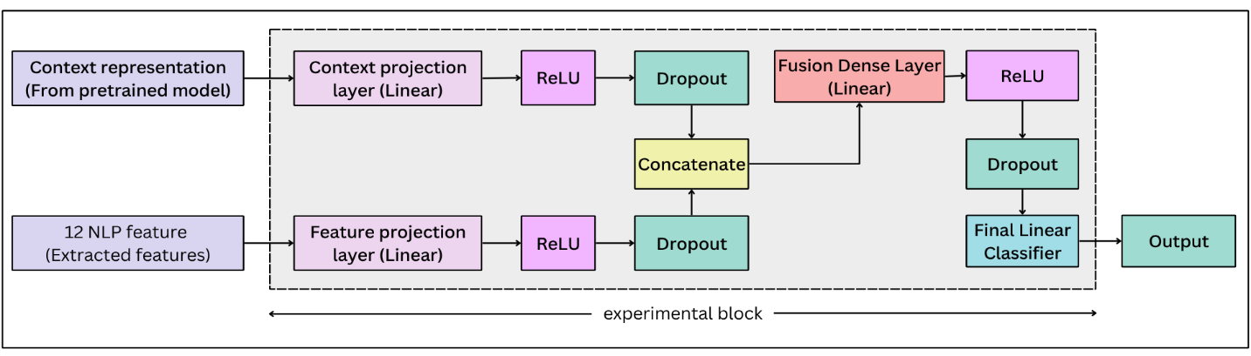
Figure 5.2.5.1: Architecture of Feature Concatenation Model
In the first architecture, the first-token representation from DeBERTa (equation i) is used as the overall contextual representation:
$$h_{c}=H\left[:, 0, :\right]$$
This 1024-dimensional representation is then passed through a linear projection and activation to obtain a compact representation for the hybrid model. In parallel, the 12 handcrafted NLP features are projected into the same feature space. Dropout is applied to both branches to reduce overfitting.
The two resulting representations are then concatenated to preserve information from both the contextual and handcrafted feature branches:
$$h_{concatenate}=\left[h_{c}^{'} ; h_{f}^{'}\right]$$
The concatenated representation is passed through a fusion dense layer with ReLU activation and dropout. Finally, a linear classification layer produces two output values corresponding to the Safe Email and Phishing Email classes.
Hybrid Architecture 2: Gated Fusion
The second hybrid architecture extends the feature concatenation approach by introducing a gated fusion layer between the two feature branches and the fusion dense layer. The architecture combines the contextual representation from the pretrained DeBERTa-v3-large model with the 12 handcrafted NLP features.
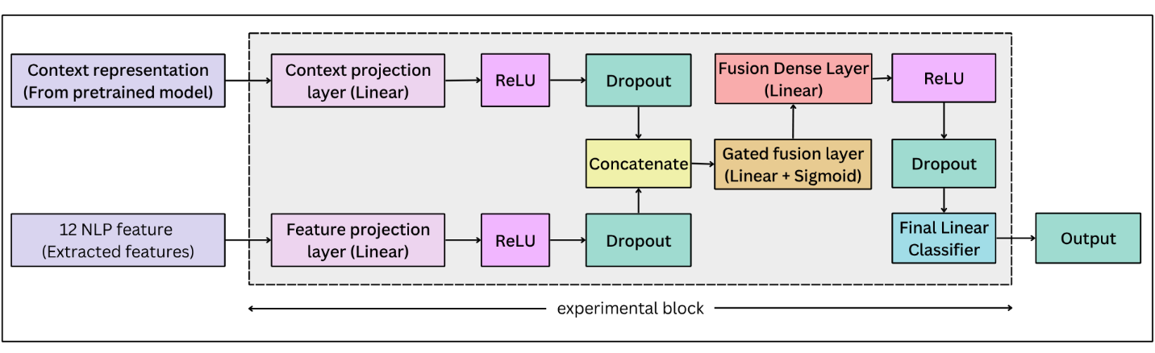
Figure 5.2.5.2: Architecture of Gated Fusion Model
The contextual representation and the 12 NLP features are first passed through separate linear projection layers, followed by ReLU activation and dropout. Both branches are projected into a 256-dimensional representation before fusion.
The two projected representations are then concatenated and provided to the gated fusion layer, which uses a linear transformation and sigmoid activation to learn a gate for combining the two information sources:
$$g= σ\left(W_{g}\left[h_{c}^{'}; h_{f}^{'}\right]+b_{g}\right)$$
The gated representation is then passed to the fusion dense layer, followed by ReLU activation and dropout. Finally, the linear classifier produces the two classification outputs: Safe Email and Phishing Email.
Hybrid Architecture 3: Attention Pooling
The third hybrid architecture extends Draft 2 by introducing an attention pooling layer to obtain the contextual representation from the pretrained DeBERTa-v3-large model. The architecture combines the contextual information with the 12 handcrafted NLP features through separate processing branches.
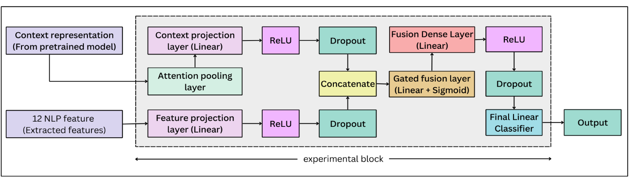
Figure 5.2.5.3: Architecture of Attention Pooling model
Instead of directly using the first-token representation, the token-level representations generated by DeBERTa are passed through the attention pooling layer to obtain a weighted contextual representation. This representation is then passed through a linear projection layer, followed by ReLU activation and dropout. In parallel, the 12 handcrafted NLP features are passed through a feature projection layer, ReLU activation, and dropout.
In this architecture, for the token representation hi, attention score is first calculated, and the scores are converted into normalised attention weights using a SoftMax function.
$$s_{i}= w_{a}h_{i}+b_{a}$$

$$a_{i}=softmax\left(s_{i}\right)$$
The contextual representation is then obtained as the weighted sum of the token representations:
$$h_{c}=\sum_{i}{a_{i}h_{i}}$$
This allows the model to assign greater importance to tokens that contribute more strongly to the overall email representation. The resulting contextual representation is then passed through the context projection layer, ReLU activation, and dropout. In parallel, the 12 handcrafted NLP features are processed through the feature projection layer, ReLU activation, and dropout. The two processed representations are concatenated and passed through the gated fusion layer. The resulting fused representation is then processed by the fusion dense layer, ReLU activation, and dropout before the final linear classifier produces the Safe Email and Phishing Email predictions.
5.2.6 Model Optimization
Model optimization was conducted to investigate how different architectural components and training configurations affected email classification performance. The optimization process consisted of architectural experimentation and hyperparameter experimentation.
A. Architectural Optimization
The hybrid architectures were developed progressively by introducing additional components to the pretrained transformer models. The experiments investigated the use of the 12 handcrafted NLP feature branch, feature projection, feature concatenation, gated fusion, attention-based token pooling, fusion layers, and dropout.
B. Hyperparameter optimization
For the hybrid architectures, the main training parameters considered were learning rate, batch size, gradient accumulation, sequence length, and numerical precision. The models used a maximum sequence length of 512 tokens and a learning rate of $1 × {10}^{-5}$. FP32 precision was used for stable training.
For the larger DeBERTa-based architectures, batch size and gradient accumulation were adjusted according to GPU memory requirements. Architecture 2 used batch size 2 with gradient accumulation of 8 steps, together with gradient checkpointing to address memory limitations. The same training configuration was maintained for the subsequent DeBERTa hybrid experiments to support a consistent comparison.
5.2.7 Proposed Gated Hybrid DeBERTa Model
The proposed architecture combines the contextual representation from DeBERTa-v3-large with the 12 handcrafted phishing-related NLP features. The two information sources are processed through separate branches before they are fused.
The DeBERTa-v3-large branch receives the preprocessed email text and produces a contextual representation from the Transformer encoder. This representation is passed through a linear projection layer, ReLU activation and dropout. In parallel, the 12 handcrafted features are passed through a separate feature projection layer, followed by ReLU activation and dropout. Both branches are projected into a 256-dimensional feature space before fusion.
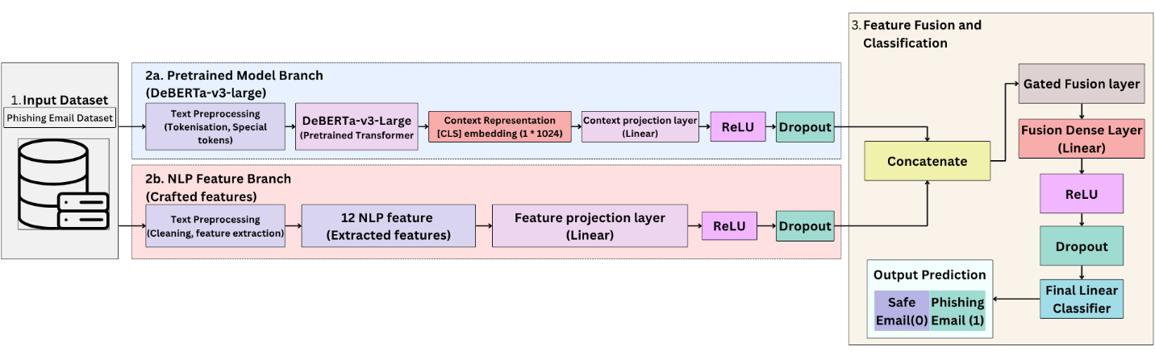Figure 5.2.7.1: Architecture of Gated Hybrid DeBERTa Model
The two projected representations are then concatenated and provided to the gated fusion layer. The gate uses a linear transformation with sigmoid activation to learn the contribution of the contextual and handcrafted feature representations. The resulting fused representation is passed through a fusion dense layer with ReLU activation and dropout. A final linear classifier produces the two output classes: Safe Email and Phishing Email.
This architecture allows the model to use both contextual information learned from the email text and explicit phishing-related indicators within a single classification framework.
5.2.7 Model Training and Evaluation
The models were trained using the training dataset, while the validation set was used to monitor performance during model development. Training configurations were selected according to the requirements of the individual transformer architecture. The experiments used different sequence lengths, batch sizes, learning rates, and training configurations depending on the model. FP32 precision was used across the experiments to maintain stable model training.
For model evaluation, the same held-out test set was used for all baseline and hybrid architectural models. This provided a consistent basis for comparison between the different approaches.
Evaluation Metrics
To evaluate the performance of the proposed model, many metrics have been assessed. A true positive (TP) is when the model accurately detects a positive instance. A true negative (TN) occurs when the model accurately detects and classifies a situation as negative. False positives (FP) and false negatives (FN) occur when the model makes erroneous predictions of positive and negative instances, respectively. Accuracy refers to the proportion of accurate predictions produced by the model, expressed as a percentage.

Accuracy
Measures the overall correctness of the model. It is the ratio of correctly predicted observations (both true positives and true negatives) to the total observations (Sokolova and Lapalme 2009).
$$accuracy= \frac{TP+TN}{TP+TN+FP+FN}$$

Precision
Measures the accuracy of positive predictions. It is the ratio of correctly predicted positive observations to the total predicted positive observations (Sokolova and Lapalme 2009).
$$precision= \frac{TP}{TP+FP}$$

Recall
Measures the fraction of actual positives that are correctly identified. It is the ratio of correctly predicted positive observations to all observations in the actual class (Sokolova and Lapalme 2009).

$$recall= \frac{TP}{TP+FN}$$

F1 Score
The harmonic mean of precision and recall. It provides a single metric that balances both precision and recall (Sokolova and Lapalme 2009).

$$f1 score=2× \frac{precision×recall}{precision+recall}$$

